Jenkins Setup and Maven Project Configuration Guide

1. Introduction
This guide walks you through setting up:
- An AWS EC2 instance for Jenkins installation
- Installing necessary software packages
- Configuring Jenkins with Maven integration
- Building your first Maven project in Jenkins

2. Setting Up an AWS EC2 Instance
2.1 Launch an EC2 Instance
- Log into the AWS Management Console.
- Navigate to EC2 Dashboard → Instances → Launch Instance.
- Configure your instance with the following settings:
Setting | Value
Operating System | Red Hat Enterprise Linux 9
vCPUs | 2
Memory | 4 GB RAM
Storage | 50 GB (General Purpose SSD)
Ports to open | SSH (22), HTTP (80), Custom TCP (8080)
Tip: Port 8080 is needed to access Jenkins through a web browser.
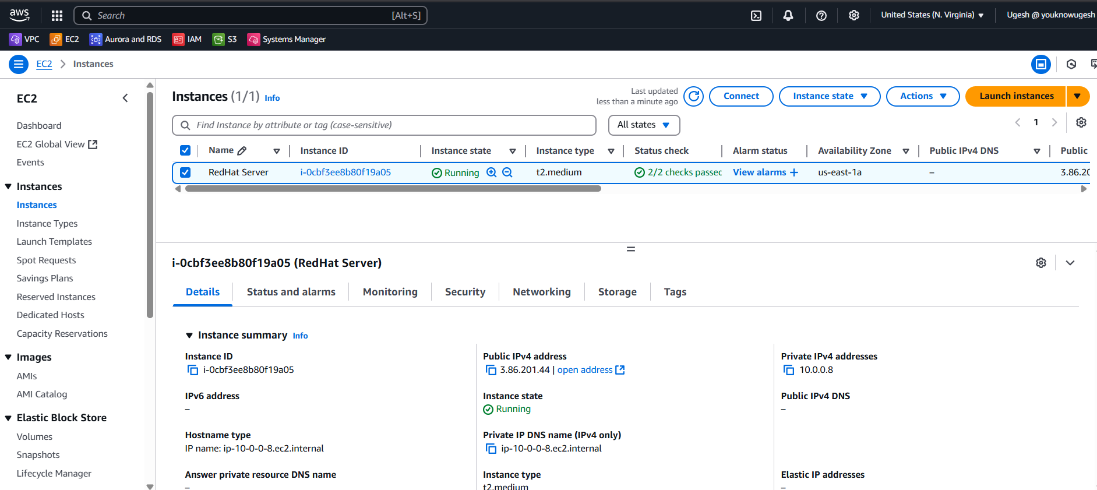

3. Connecting to Your Instance
Once your instance is running, connect via SSH using Putty:
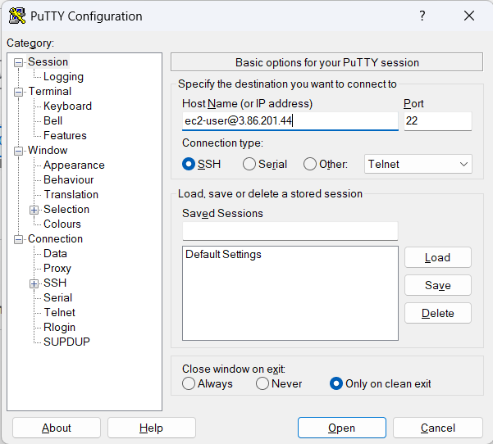

4. Installing Required Software on the Server
After connecting to the instance, run the following commands to install all required packages.
# Update system packages
sudo yum update -y
sudo yum upgrade -y
# Install OpenJDK 21
sudo yum install java-21-openjdk java-21-openjdk-devel -y
# Install Git
sudo yum install git -y
# Install Maven
sudo yum install maven -y
# Install Wget
sudo yum install wget -y
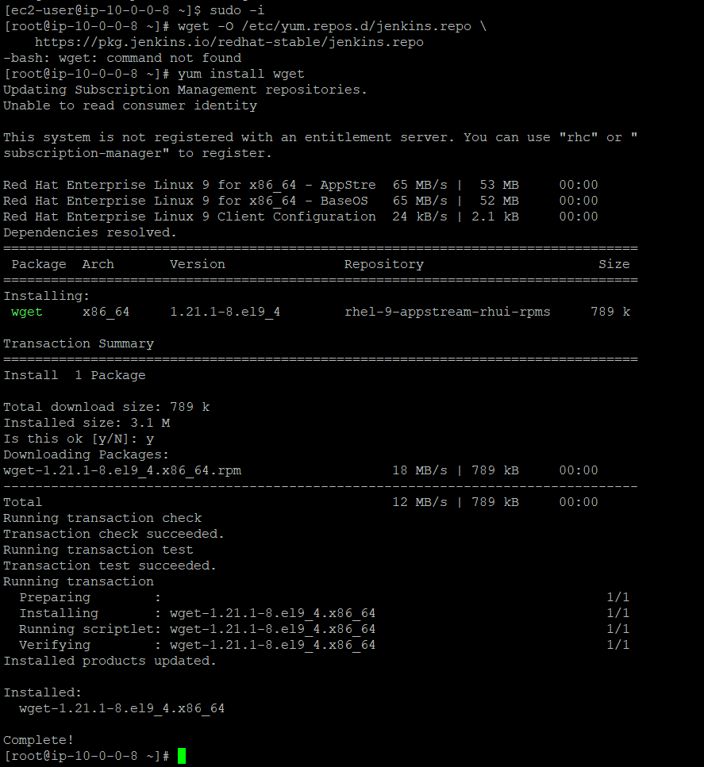

5. Setting Up Jenkins
5.1 Install Jenkins
First, add the Jenkins repository and import the Jenkins GPG key:
# Add Jenkins repository
Yum upgrade -y
sudo wget -O /etc/yum.repos.d/jenkins.repo https://pkg.jenkins.io/redhat-stable/jenkins.repo

# Import GPG key
sudo rpm --import https://pkg.jenkins.io/redhat-stable/jenkins.io-2023.key
Now install Jenkins:
# Install Jenkins
sudo yum install jenkins -y
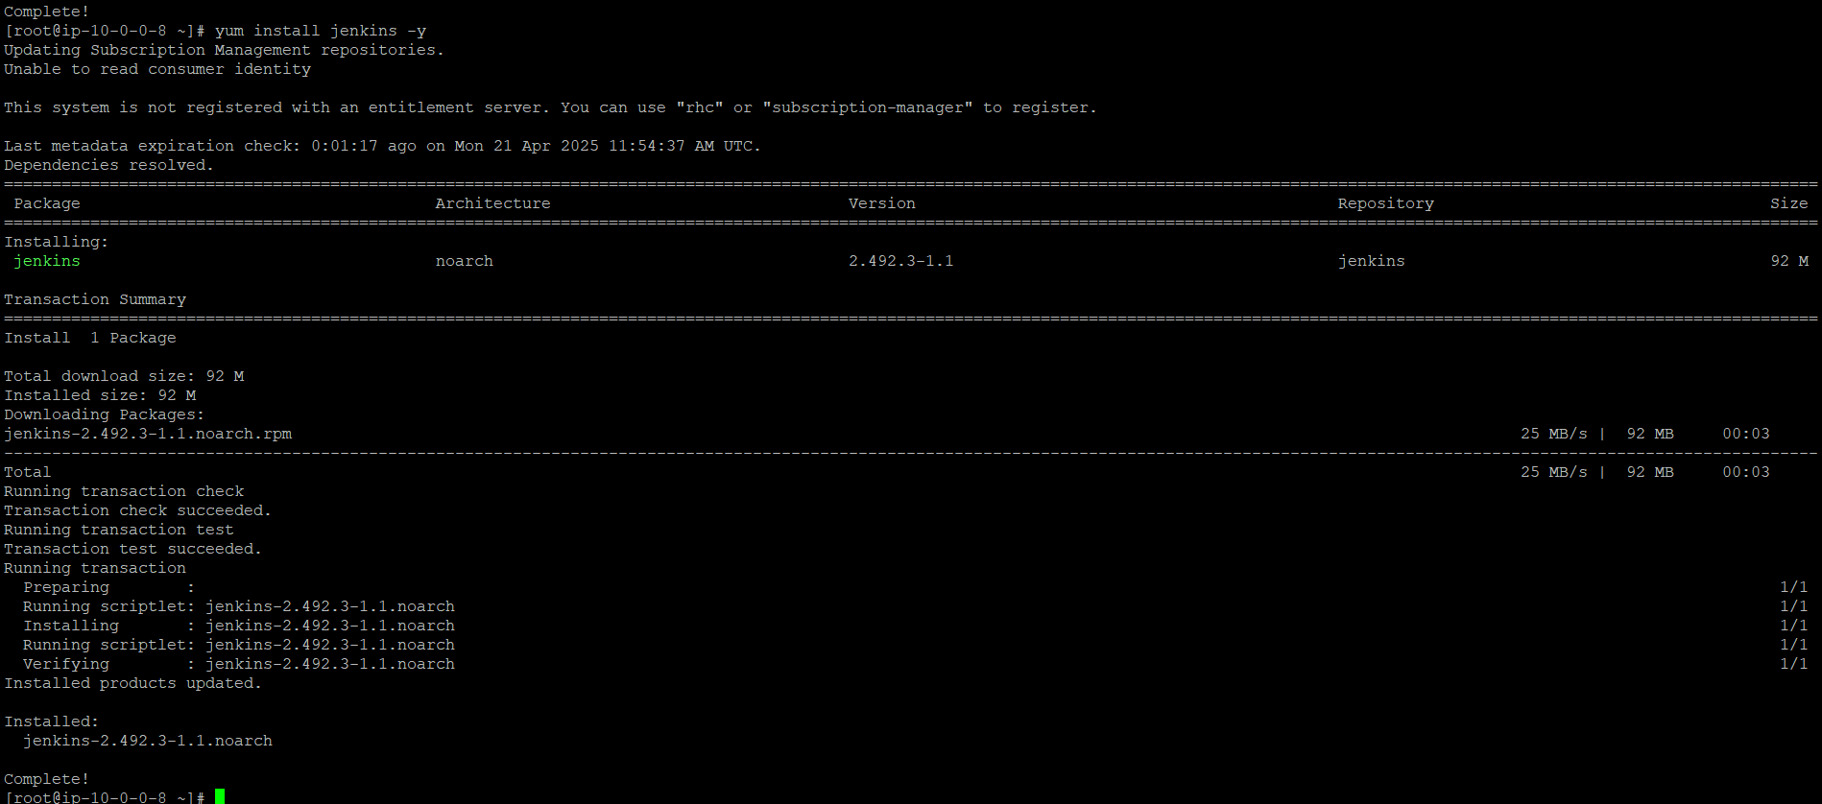
Enable and start the Jenkins service:
sudo systemctl enable jenkins
sudo systemctl start jenkins
Check Jenkins status:
sudo systemctl status Jenkins
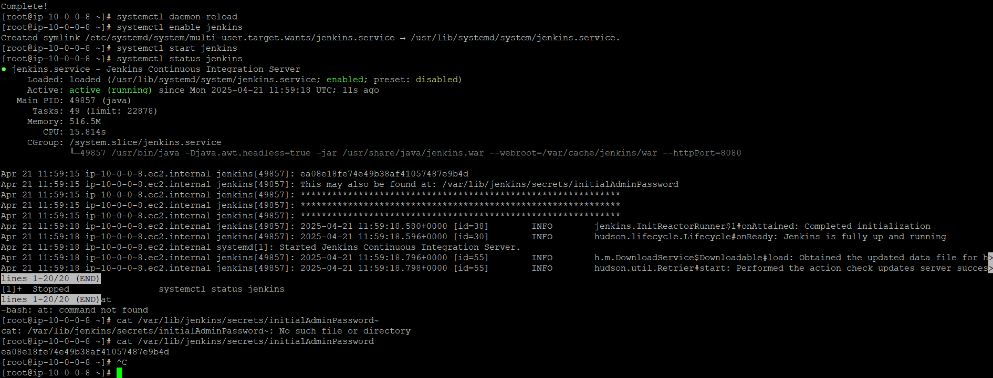

6. Access Jenkins Web Interface
- Open your browser and go to:
http://<Public-IP>:8080
- To unlock Jenkins for the first time, retrieve the initial admin password:
sudo cat /var/lib/jenkins/secrets/initialAdminPassword
- Paste the password into the Jenkins web interface and create your admin user.
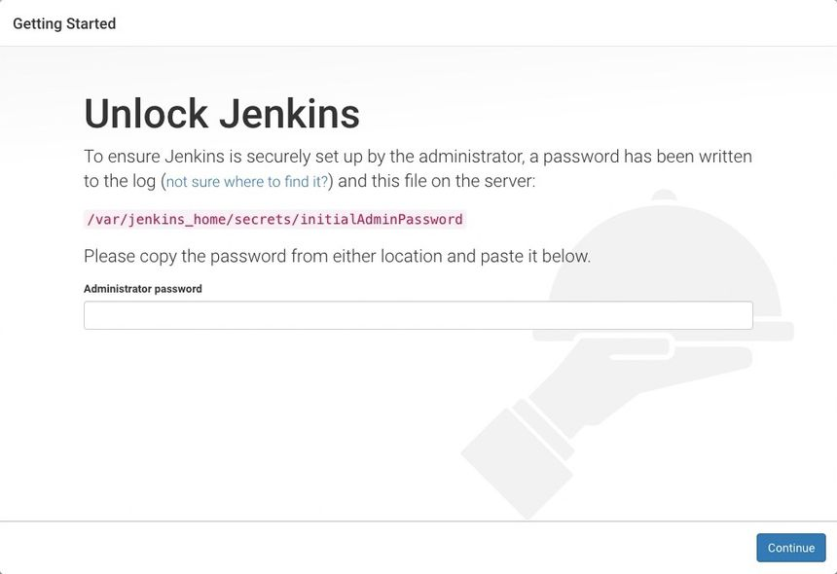

7. Install Essential Jenkins Plugins
During the setup wizard or afterward, install the following plugins:
- Git Plugin
- Pipeline Plugin
- Blue Ocean Plugin
- Maven Integration Plugin
- Stage View Plugin
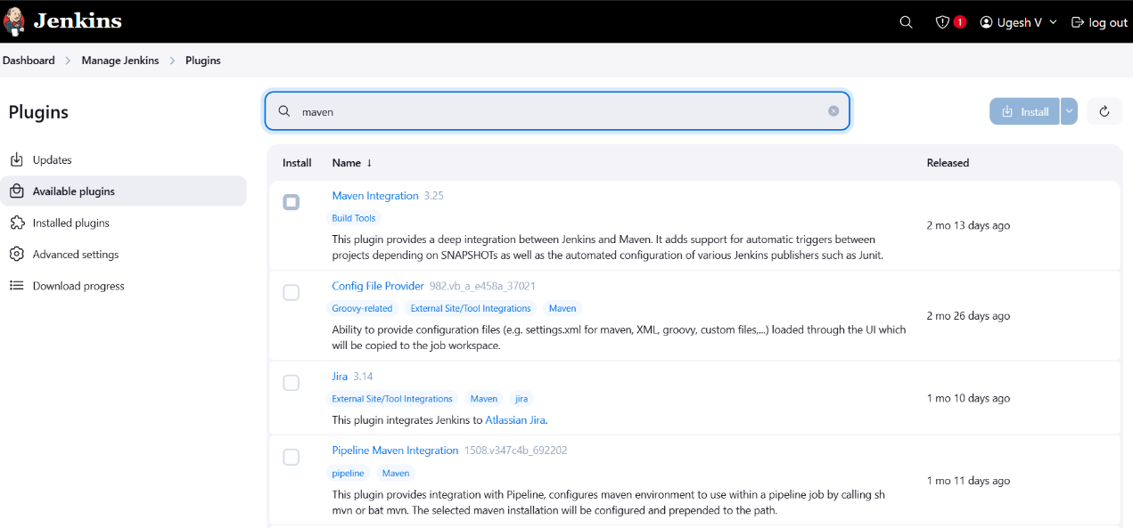
8. Configure Tools in Jenkins
8.1 Configure Maven
- Go to Manage Jenkins → Global Tool Configuration.
- Under Maven, click Add Maven.
- Provide a name (e.g., Maven-3.6.3) and install automatically or define the Maven path manually(/usr/share/maven).
Verify Maven installation on the server:
mvn -v
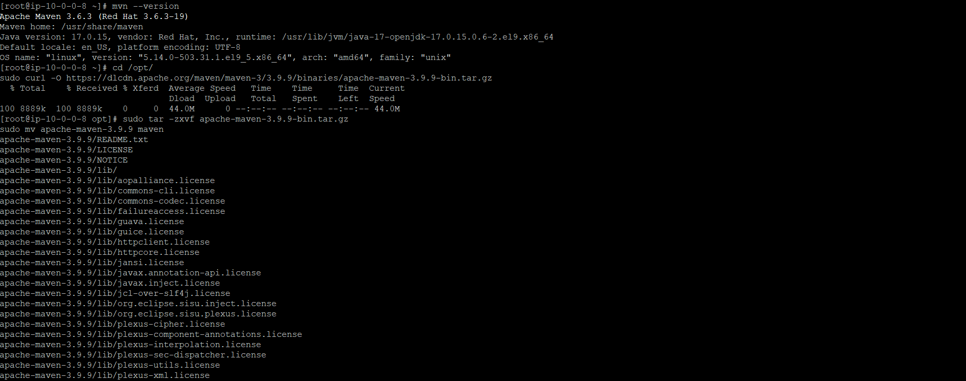

9. Create and Configure a Maven Project in Jenkins
9.1 Prepare a Git Repository
Create a Git repository and push your Java Maven project, ensuring it contains a valid pom.xml file.
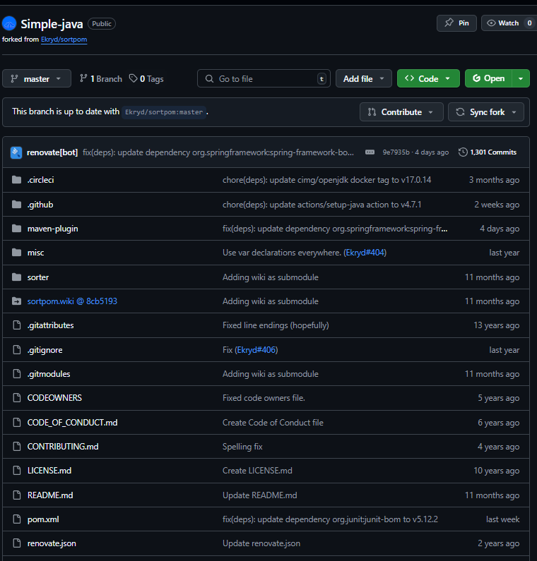
9.2 Create a New Jenkins Job
- In Jenkins, click New Item.
- Name your project.
- Select Maven Project and click OK.
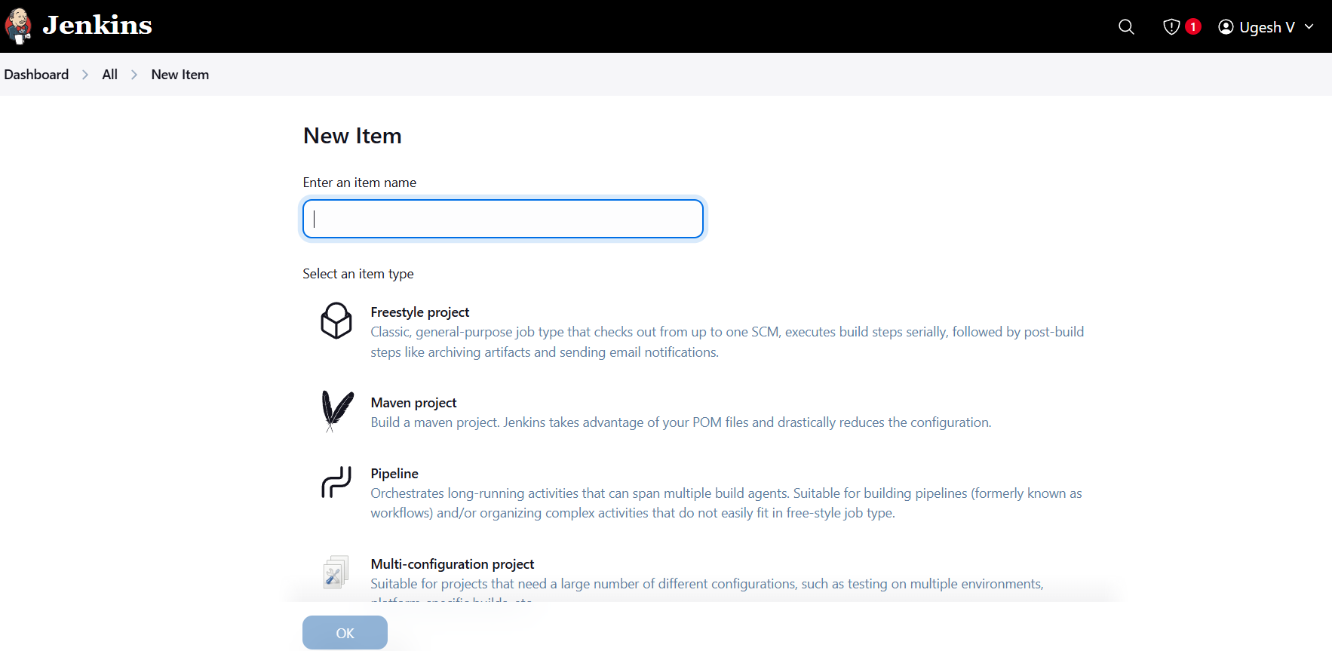

9.3 Configure the Job
- Source Code Management:
  - Select Git.
  - Enter your repository URL.
  - Add credentials if needed.
- Build Section:
  - Root POM: pom.xml
  - Goals and Options: clean install
- Post-build Actions: (Optional)
  - Archive the artifacts generated (.jar, .war).
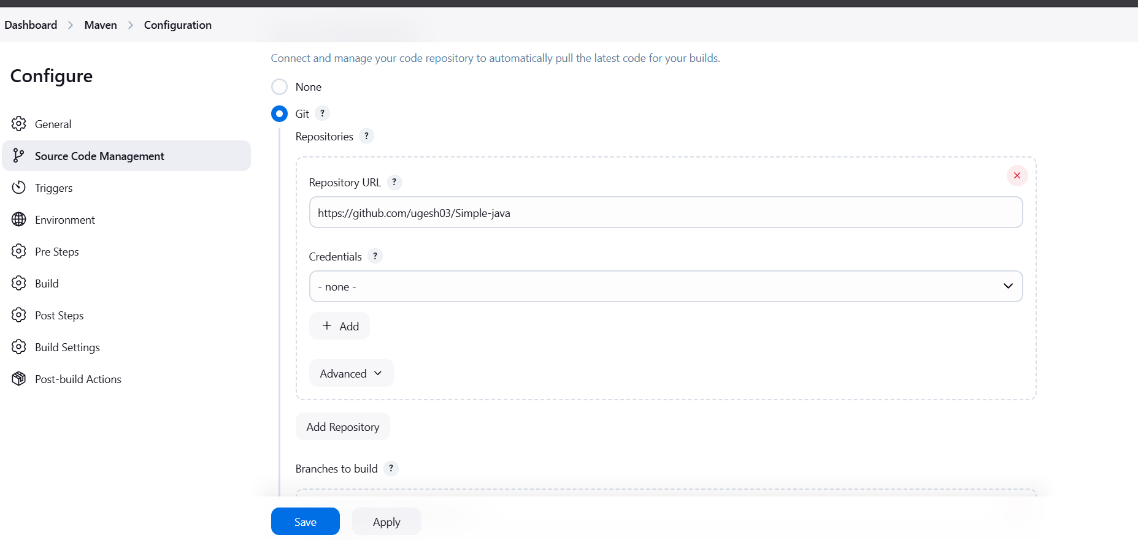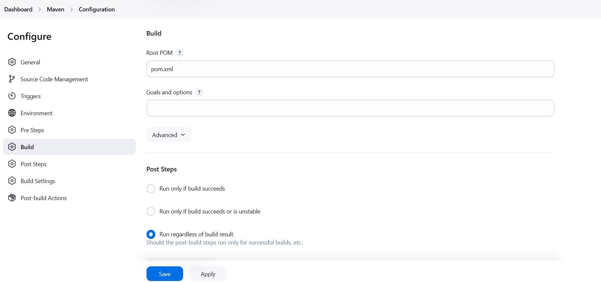
9.4 Build and Verify
- Click Build Now.
- Monitor the console output for success.
A successful build will typically show:
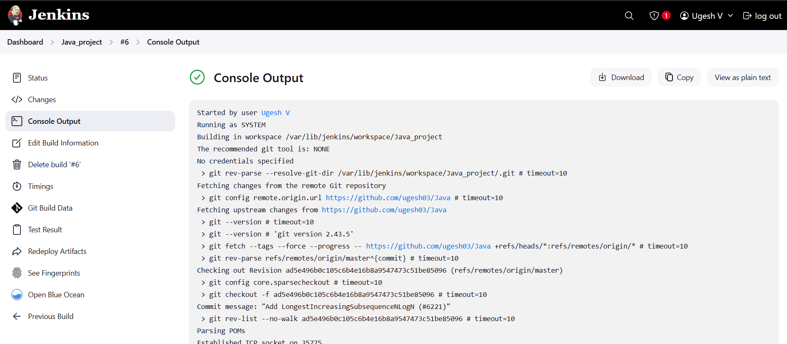

Troubleshooting:
Get error with JDK version, so upgrade the JDK version with Jenkins compatibility.
Configure Maven home directory in Jenkins tools. It was not taken properly in the initial stage.
Mention the pom.xml file with correct path.

sudo yum update -y
sudo yum install java-21-openjdk java-21-openjdk-devel -y
sudo yum install git -y
sudo yum install maven -y
sudo yum install wget -y
Yum upgrade -y
sudo wget -O /etc/yum.repos.d/jenkins.repo https://pkg.jenkins.io/redhat-stable/jenkins.repo
sudo rpm --import https://pkg.jenkins.io/redhat-stable/jenkins.io-2023.key
sudo yum install jenkins -y
sudo systemctl enable jenkins
sudo systemctl start jenkins

